Networks - Ethernet Cables

# Types of Cable

## Categories

There are various different standards of ethernet cable which have a max length of 100m:

* 10BASE-T - Cat-3 (4-wires)
* 100BASE-T - Cat-5 (4-wires)
* 1000BASE-T - Cat5e (8-wires)
* 10GBASE-T - Cat6a
* 40GBASE-T - Cat8

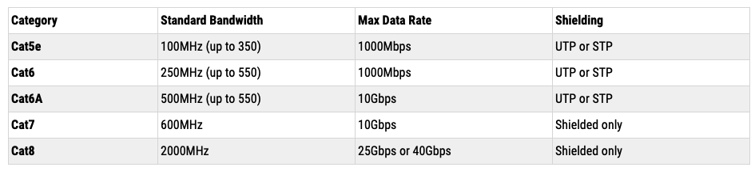

The Category (Cat-n) of the cable is based on the quality and number of wires included.

Cables longer than 100m can cause late collsions.

## Interfaces

Ethernet has two types of interface for connecting devices:

* Medium Dependent Interface (MDI) - send data between switch and machine
* Medium Dependent Interface Crossover (MDI-X) - send data between two machines

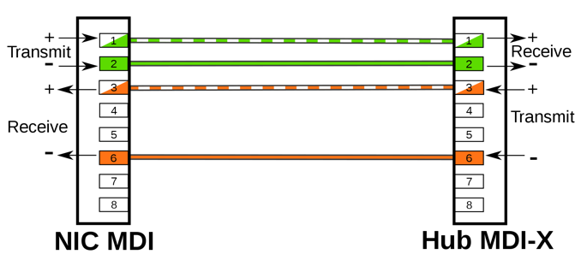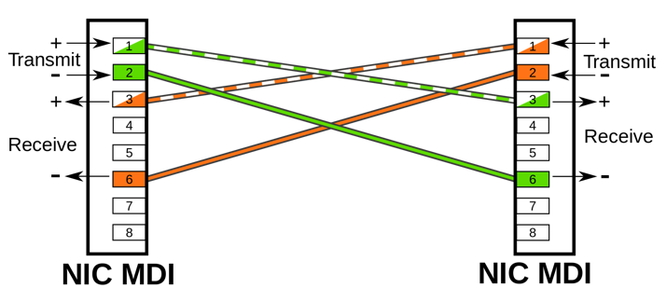

Pre 100BASE-T, two types of cable were required for each type of network interface, straight-through and cross-over. Each cable had different pin outs to match up transmission and receiving cables on interfaces (TX/RX).

Since 1000BASE-T it became standard to include Auto MID-X in the Network Interface Card (NIC). Auto MID-X allows devices to automatically negotiate and decide which type of interface was required, allowing the same type of cable to be used for all device connections.

# RJ45 Pinout

## T-568B

Used for straight through cable:

